# ***5 What Is Antillery?***

As discussed in the Introduction, Antillery draws from the tradition of 2D artillery games, particularly the Worms series. It builds on the genre's core loop of indirect, physics-based combat within a turn-based system while introducing new thematic and mechanical directions. This section examines Antillery's place within the artillery genre, outlining its core gameplay features and thematic goals.

## 5.1 Genre Classification

Antillery fits the classification of a 2D turn-based strategy game. It belongs to the artillery subgenre, a branch of turn-based strategy centered around indirect, physics-based projectile combat between players. Artillery games typically involve players alternating turns to reposition units, aim and fire projectiles, and adapt to environmental variables such as wind or destructible terrain. These features create emergent gameplay scenarios that are easy for most players to pick up but have a level of strategic depth that offers extensive replayability. **Table 5.1** summarizes commonly used terms for classifying artillery games like Antillery (Barton).

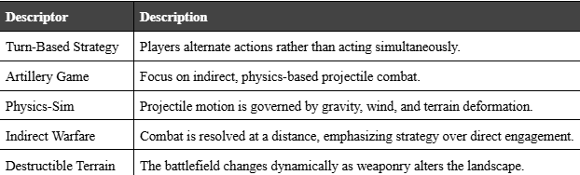

**Table 5.1.** Some commonly used terms for describing artillery games.

## 5.2 Core Gameplay Features

### 5.2.1 Core Turn Structure

Fundamentally, Antillery follows the turn-based style of combat typical of artillery games. Two to four players compete on a 2D battlefield, each taking turns repositioning their active unit, choosing weapons or tools, aiming, and firing projectiles at one another. Gravity and wind affect each shot's trajectory while impacting weapons reshape the destructible terrain throughout the match.

### 5.2.2 Local Multiplayer and Emergent Chaos

Antillery encourages local multiplayer, with two to four players sharing a single device and screen. This design brings players to the same couch as they commit absurdly large-scale destruction on the battlefield or wage acts of aggressive environmental protest on one another in real time. The game's design leans into this immediacy, turning small actions into big, game-changing, friendship-ruining moments and keeping the competition lively and unscripted. **Table 5.2** summarizes Antillery's core gameplay features.

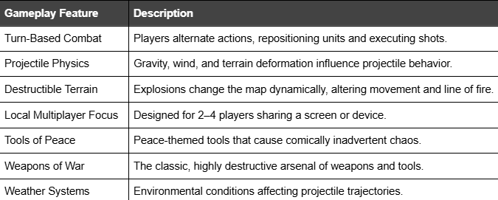**Table 5.2.** Core gameplay features that Antillery includes.

## 5.3 Inspiration

This section explores how Antillery draws its primary inspiration from the creative breakthroughs introduced by the Worms franchise. As Worms reshaped the artillery genre in its era, Antillery's goal is to be the next evolutionary step in that lineage.

### 5.3.1 Worms: Innovation of Artillery

The Worms series changed how players thought about artillery games. Instead of focusing only on careful calculations and perfect firing angles, Worms made strategy unpredictable. Humor and player mobility turned each match into something memorable, improvised, and full of surprises.

As discussed in Section 3, Barton highlights how Worms reframed artillery combat through a Monty Python-style comedic lens, replacing grim simulations with colorful, irreverent chaos (Barton). Beyond its humor, Worms gave players absolute freedom of movement. Characters could jump, crawl, and swing across the battlefield, reshaping strategies that were once upon a time reduced to firing arcs (Nuttal 26).

This shift had a lasting impact. The Worms series did not just add jokes; it redefined what an artillery game could be. Its success showed that strategy could come from chaos as easily as calculation. Antillery draws from that innovation but goes further, blending new gameplay mechanics with modern cultural satire to create a new brand of chaotic vision.

### 5.3.2 Antillery: Evolution of Innovation

Antillery's goal is to push the boundaries of artillery combat, drawing inspiration from Worms. Worms redefined artillery combat through absurdist humor and player mobility. Antillery takes its lead by blending modern cultural satire with new peace-driven gameplay mechanics.

Players still have access to traditional artillery weapons like bazookas and grenades. However, in Antillery, they may also employ new strategies centered on peace, love, and environmental restoration. Nevertheless, even actions of peace, love, and environmentalism sometimes create destructive outcomes. A sunflower might create a shielding canopy, an isolating barrier, or a bridge to strategic ground. In Antillery, every action, whether peaceful or aggressive, becomes part of a larger strategy shaped by the player.

The goal of Antillery is not to apply new paint to a formulaic experience but to evolve the artillery genre in the way that Worms did in its day. In Antillery, players must balance war and peace, challenging them to rethink what combat can be. In doing so, Antillery honors the spirit of innovation introduced by Worms while pushing the artillery genre into a new frontier.



**Figure 5.3.2.1.** *Red Ant Character Model.*



**Figure 5.3.2.2.** *Blue Ant Character Model.*